Headache

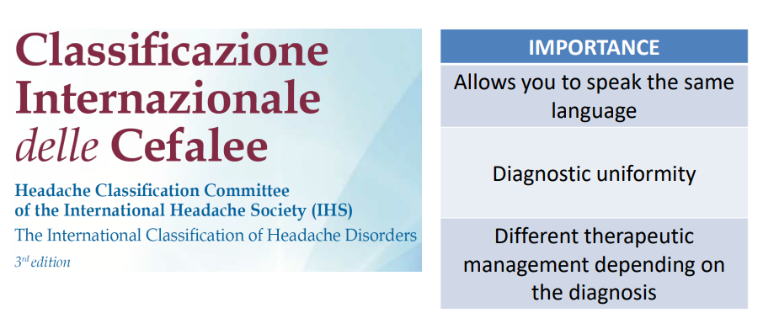

We have an international classification of headache (IHS International Headache Society for international classification of headache disorders). Allow to speak the same language and diagnostic uniformity and different therapeutic management depending on the diagnosis

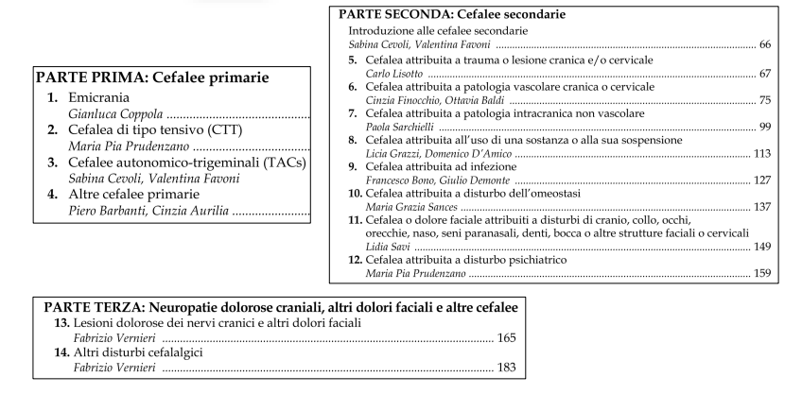
In the classification we have 3 parts:
- Primary headaches: the synonyms and diagnosis himself
- Related to other diseases
- Neuropathic Cranial Pain, Other Facial Pains, and Various Headaches

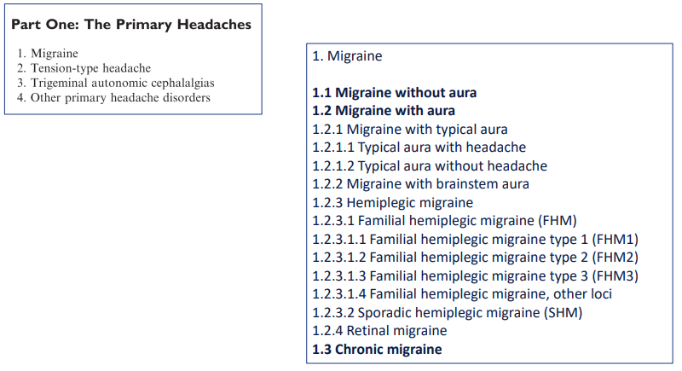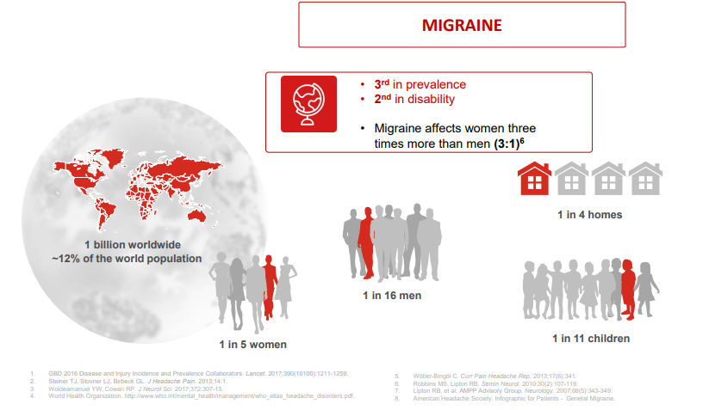
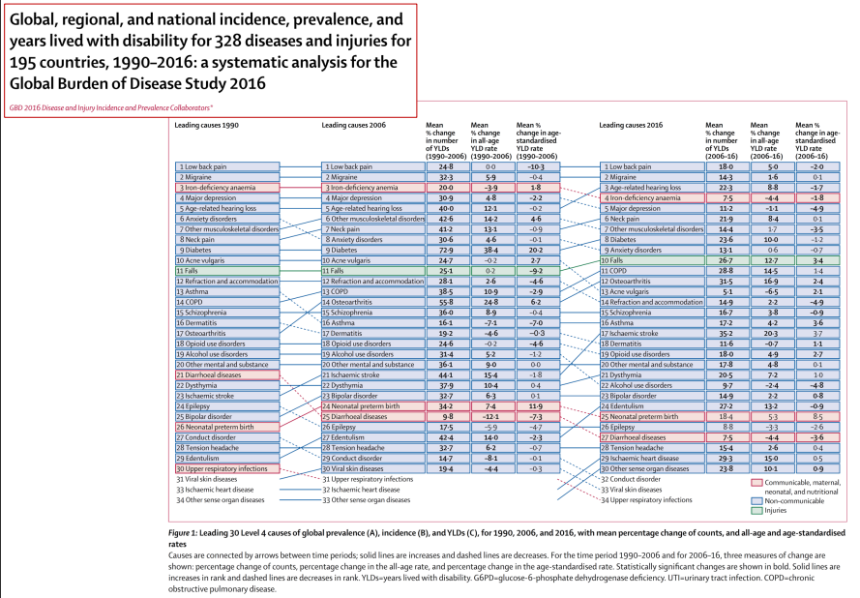

Migraine: most important subtype of headache. 1 billion worldwide suffer from migraine (around 12% of population). Is 3rd in prevalence and 2nd in disability. It affects 1 in 5 women, 1 in 16 men and 1 in 11 children. It affects women three times more than men.

It humpers all the life behavior of patients suffering. Women are more affected than men.

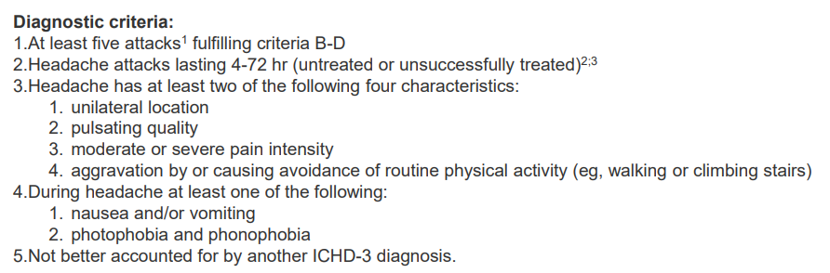

We have specific diagnostic criteria. We want to have specific diagnosis that we need to fulfill to have a migraine diagnostic
Migraine is not just the pain itself, it’s a cyclic neurological disease.
Along with pain phase, we have other symtpoms like craving, nausea, tireness and so on.
Some patients have aura.

It should be accompanied by nausea or photophobia

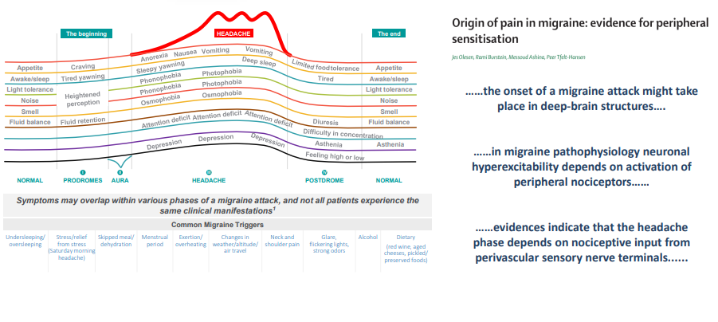
We have periods in which people are completely normal without pain but along with headache we have different synonyms.

We could also have a bottom phase. One pain phase can last 72 hours.

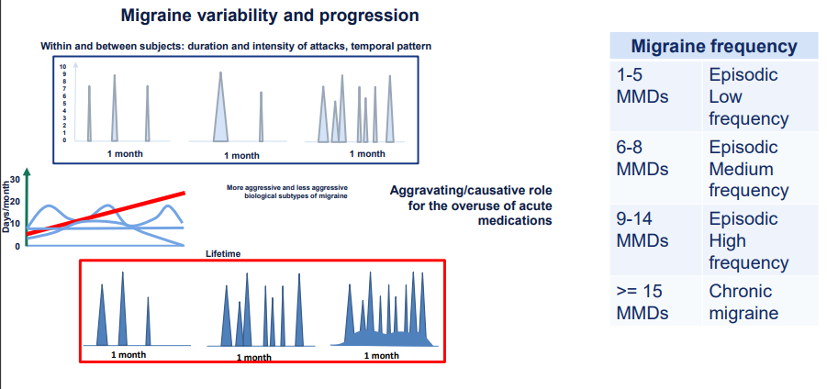
Migraine is completely different between patients, it could be much disabled or not. We divide in episodic, medium or high frequency or chronic (if extremely frequent)

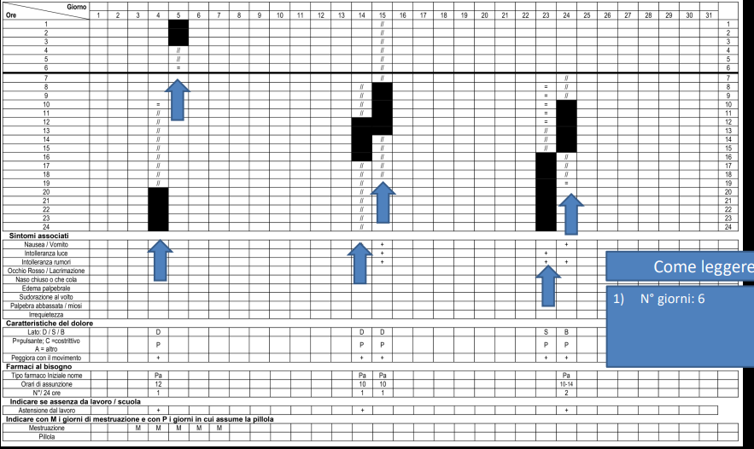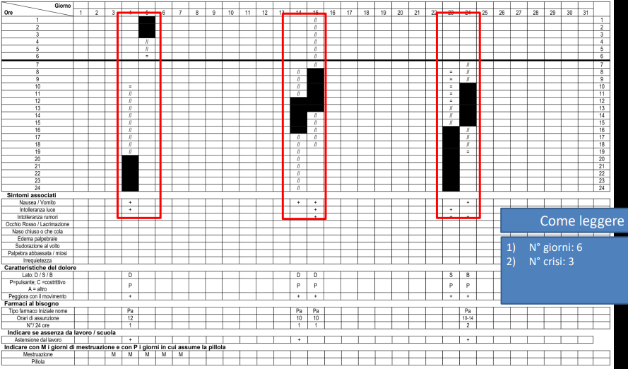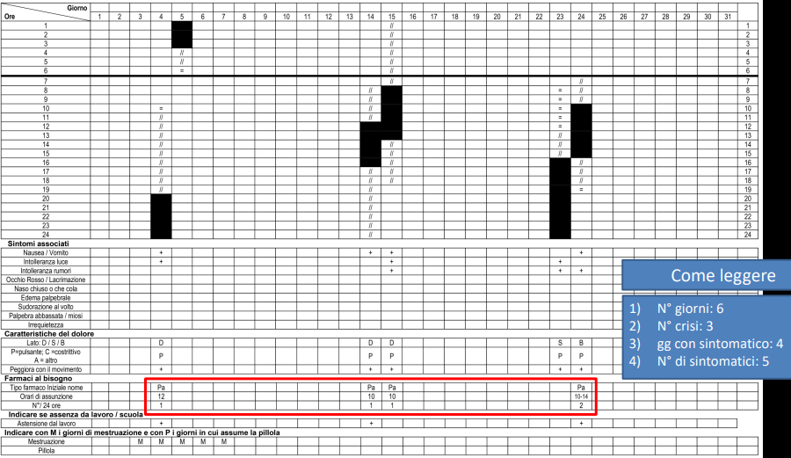

Migraine with typical aura
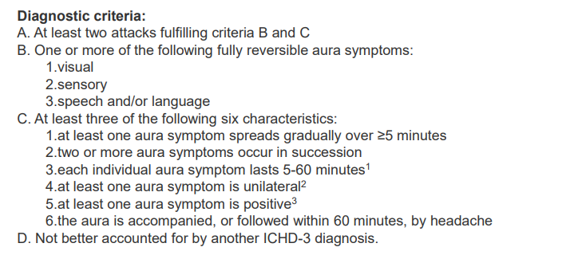
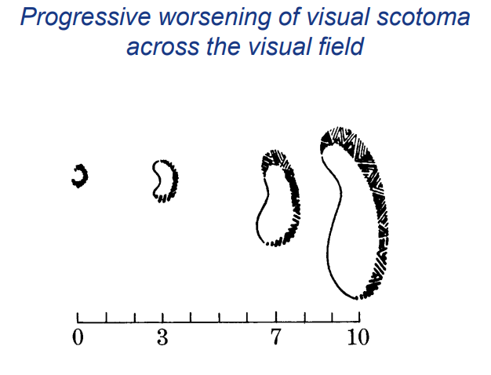
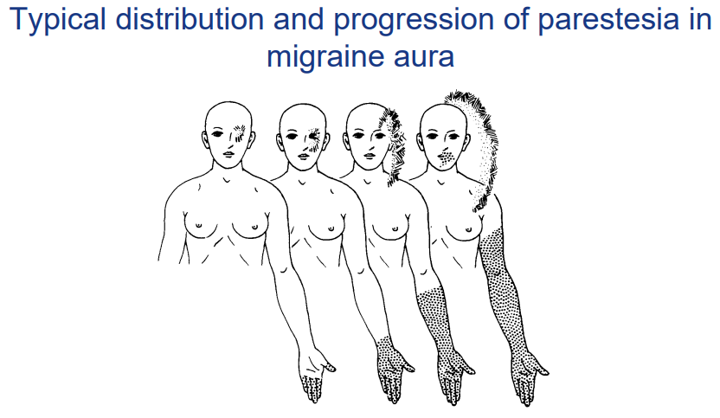

Migraine is completely different between patients.
Headache diary, patients need to fill the diary. Duration of the attack, frequency…
Some specific subtypes, like 30% of patients' pain phase could be preceded by aura.
First time with an aura they are really scared that it could be a stroke. It’s progressive.
Some other symptoms like parestesia.

Headache diary (now is electronic) to apply also statistics.

There are very specific subtypes. The pain phase could be preceded by AURA. Aura last 1h per synonyms

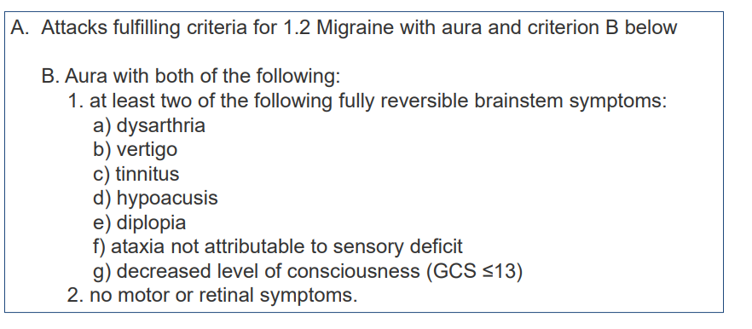
we could have some other symptoms

There exist patients with only migraine without aura, patients with only migraine with aura or both of them.

13% patients with migraines have aura.

could be other symptoms
- dysarthria
- vertigo
- tinnitus
- hypoacusis
- diplopia
- ataxia not attributable to sensory deficit
- decreased level of consciousness (GCS ≤ 13)

but those are very severe

HEMIPLEGIC MIGRAINE
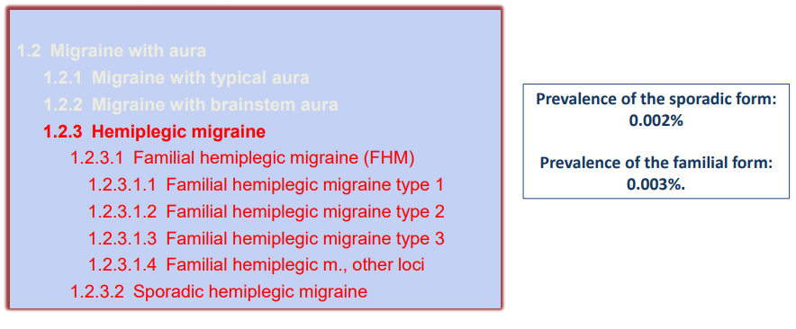

There are some mutations involved in the migraine.
Patients lacking some specific functions (sodium channels,...)

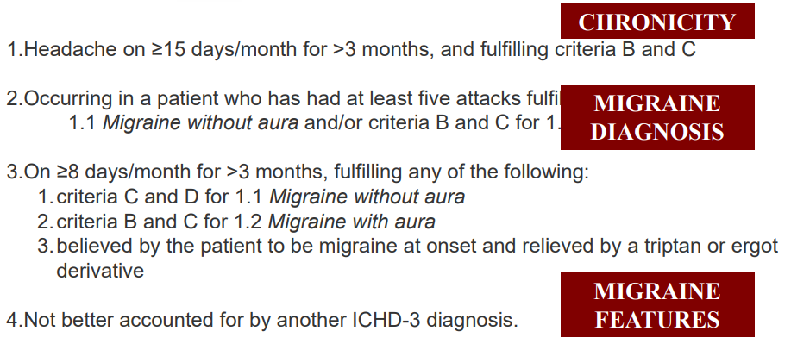
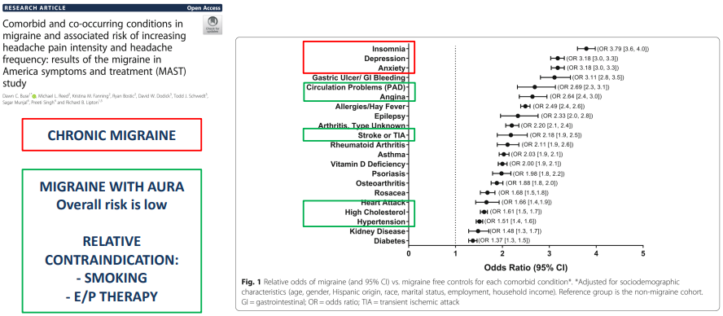
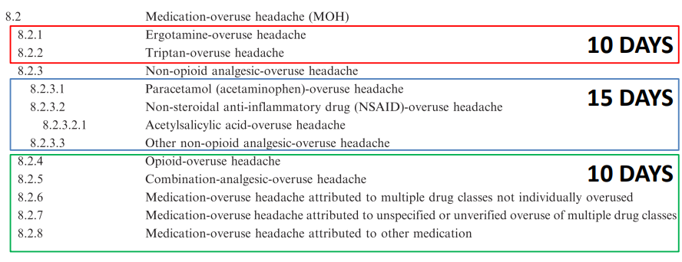
In patients with chronic migraine we have ≥ 15 days of migraine

We have some specific disability like insomnia or depression.

With migraine with AURA slight increase of stroke

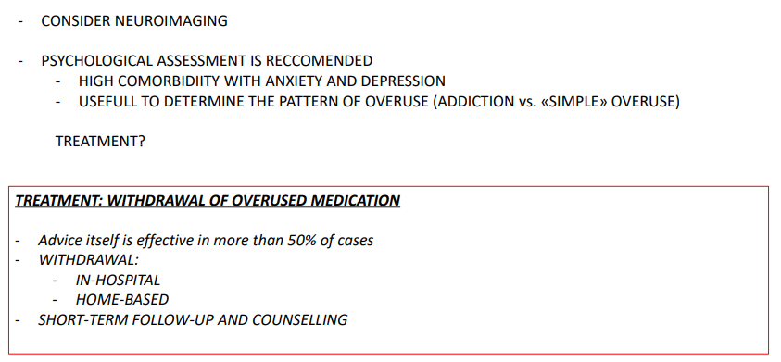
Along with chronic migraine we could have a secondary headache. Patients should take pills to alleviate the pain

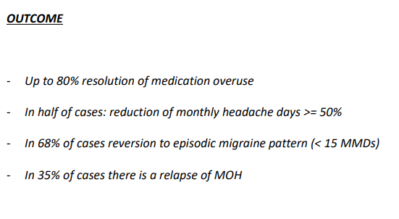
We need to advise the patient to take analgesics.
Treatment: withdrawal of overused medication.

Most effective is withdrawal from analgesics.

80% of cases with withdrawal resolution of medical overuse.

Brain activation correlates with migraine symptoms
Difficult to study a spontaneous migraine attack.
--
Scanner for MRI every day. Check for free migraine attacks.

13% have aura

---
a lot of AI focuses on predicting migraines. Now we have some many data, for the future AI will focus on predicting migraine attacks.

It is extremely difficult to study a spontaneous migraine attacks because you are not aware of that,

---
lot of study focus on using AI for diagnosis.

lot of date coming up orm prediscrptiona din nsurance data and try to collect data.

Only in usa 78billiosn annuaely a year,

ECNOUNTER: ever time a ptneitn go to the hospital/, … for a migrante attacks.

2 different apporahes-

----

Use 4000 training data wit test of 1818 and train 4240

the result was good, they have an area ounder the courve of 90%

They used magnetic reasonance image. All processes of image and then applied motorlearning classification. identify 6 area. were able to define amygdala

with different threshold of migranes

----
the msot important approach is not acute treatment. The most important part is to prevent treatmenet. Use drugs ot prevent

Treatment of migraine is based on an integrated approach.

Is not for all patients,

---
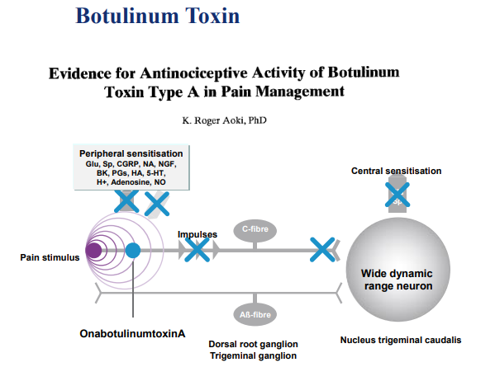
Novel drugs to perform injection in specific parts of the head. It is approved in italy for chronic migraine

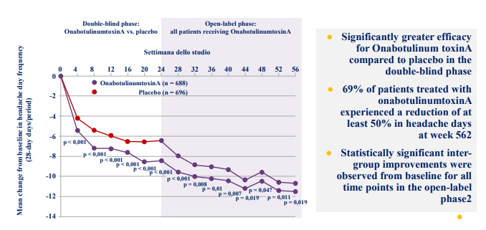
Treatment with botulinum was able to reduce migraine

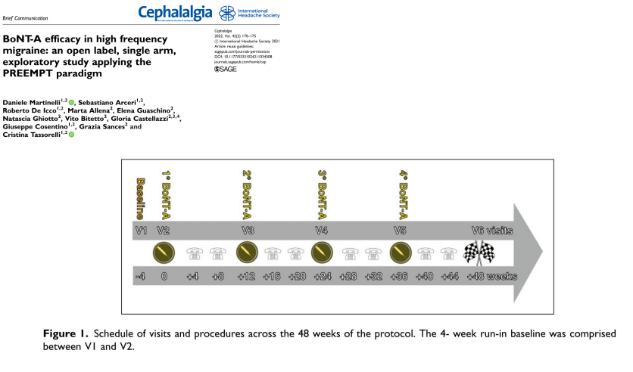

Test efficacy in botulino in high frequency migraine. Was open label without placebo and proved that even in this condition treatment with botulinum was able to reduce 4 migraine days after 24 weeks. It is effective on botulino

---

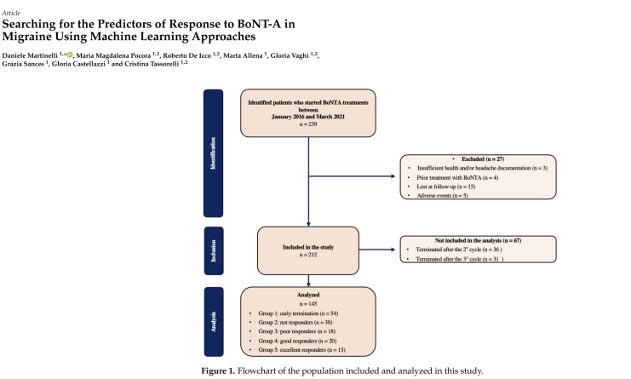
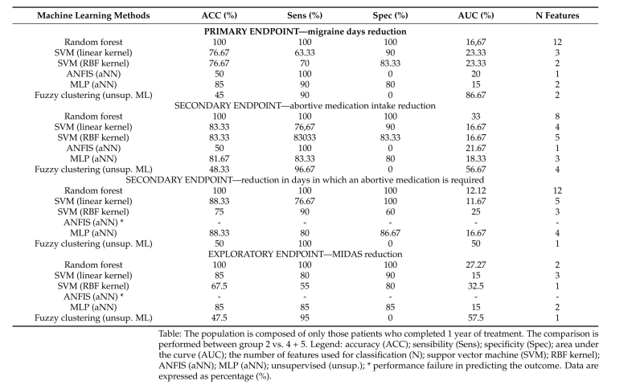
By using all the data use ML to predict efficacy. Predictors is on eof the most important field. Now there are drugs that can be expensive and are not avabile. Use prerdicots (like image of brain of patients) just to know to see who will respose very well and who not.

It is very difficult, there reverie fiew biological data related ot the desease.

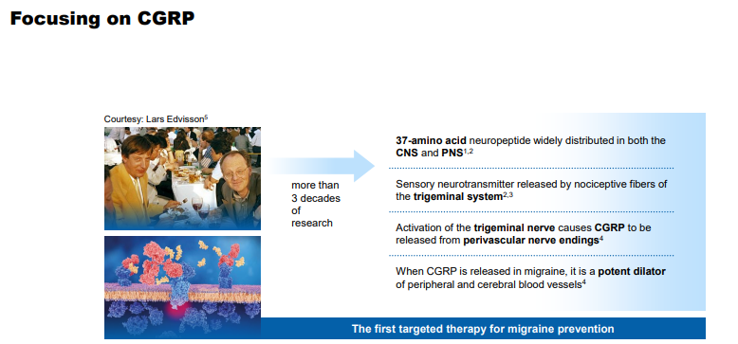
CGRP in migraine

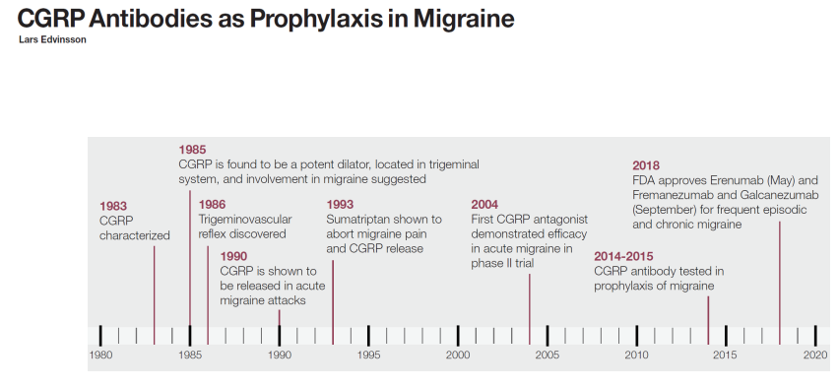
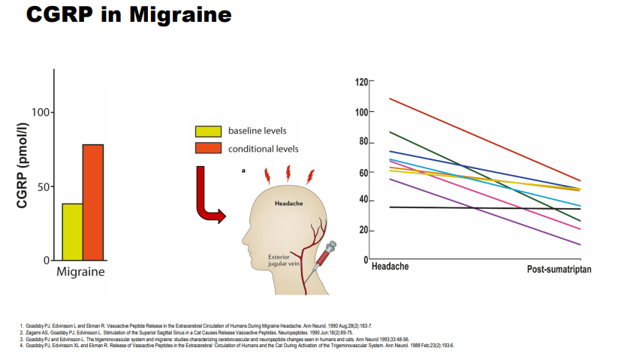
Performed in 90. If we take a blood sampling form the jugular vein we can see that CGRP is released a lot during migraine attack.

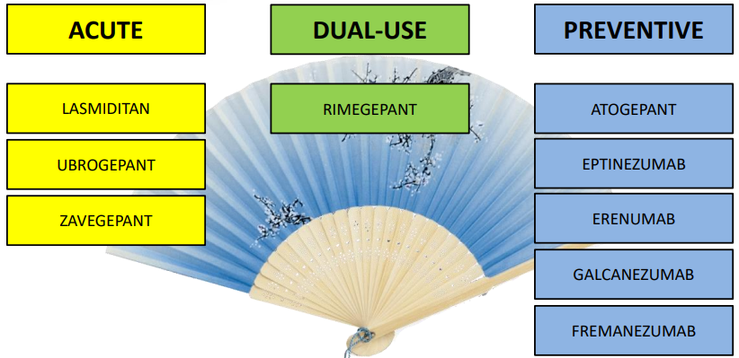
Now we have new drugs (zavegepant, lasmiditan, ubrogepant) for acute

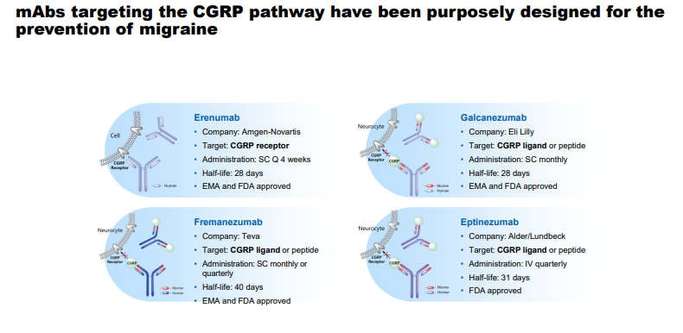
we have huge molecules that do not cross the blod+compl

most of them are humanized (at least 90% similar) and changed a lot our approach to treat migraine patient. It is given to the patient one injection per month

----
we want to know if there are some pdeicifc are with same range of frequency at the same time

So many date but not high density EG. Data points down to lower frequency in brain of patients with migrane

---
High density EEG are performed with 128 electrods. With high temporal resoltiion and high spatial resolution

Startin with 128 channels we perform connectivity analysis to check the origin of the signal and we can probide precise data regarding notes

---

all data are analysied with conventional statistic method and we use AI to have better analysis.

We have supervised approach (tell who is chronic or severe patients) but later we want to do unsupervied apporahc to see area that are similar.

---
Patient suffering cluster headache

Cluster headache
Pain is shifting sides.
There is lacrimation in the symptoms.
Patients with cluster headache there is agitation, restless ecc ecc
Different from migraine because patients want to rest and go to bed.

Cluster headkae: pain arrive in clusters and than complitely diseappaer. Usually between the change of seasons and also they a night period and specific time of the day in which attacks appears

Rhwee can be severe or very severe and one side only

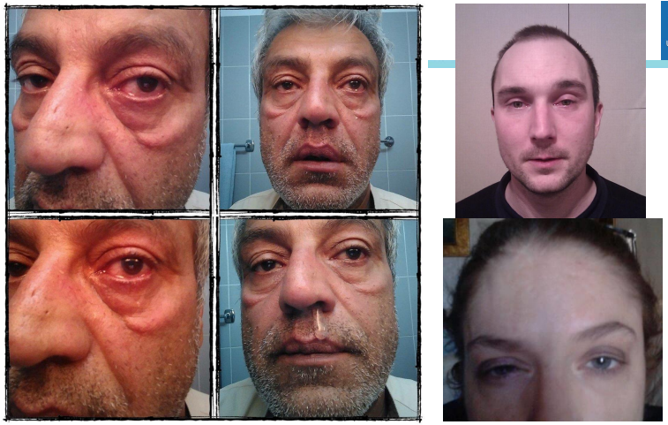
typical patient during cluster attack

have chemisis, lacrimation and in some way are easy to diagnosis

another feature differentiating patient is that under attack they want to go to bed and avoid light and noise
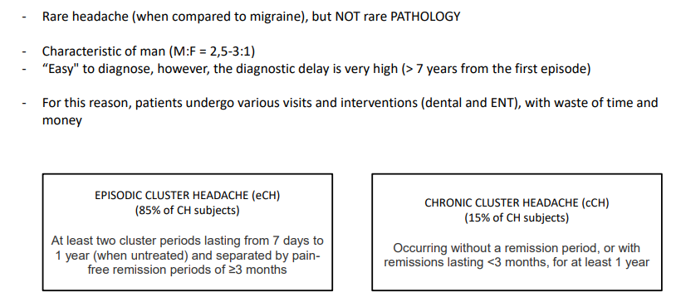
Pain is so sever that in the past there was no medication, it was called suicide headache to avoid pain.
Cluter headache it was called suicide headache.
Patietns are episodic in most cases.
In 15% of patients could be chronic.

in most cases patients are episodic (they have clusters across the years) usualyl some weeks speaprtated by 3 weeks break in which the pain disappear. Is unknown why in some periods that are attacks and in some periods there are no attacks

In a minority of patienets it is a superserver conditions, there ar eno remission periods and last less than 3 months

When we compare threament to migrante the approach to prevent are completely different

Oxygen was subsidized in italy in 2016 (before patients needs to pay for oxygen)

---
looks like chronic migrande but is hemicrania continua. One single injection is able to stop the pain

---
We recorded data from 8 active patients, only 6 performed the recording both inside and outside

